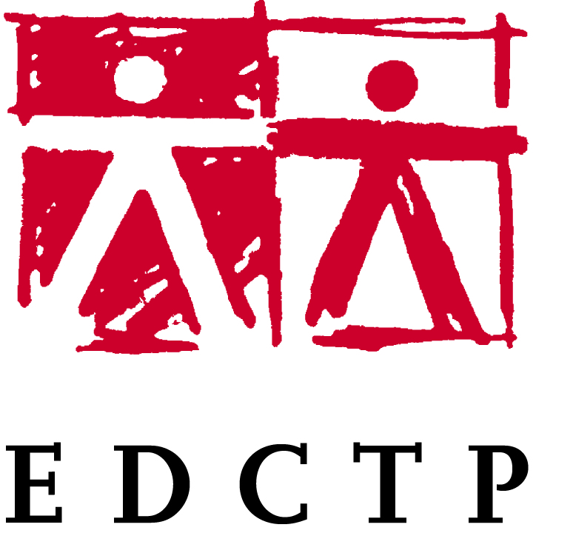

WORKSHOP: Enhancing networking among European and African scientists to close regional and gender disparities experienced in EDCTP1 and EDCTP2 funded health research capacity activities in sub-Saharan Africa

Personal details of applicant
Title |  | Gender | Female |  | Male
First Name |  | Surname
Date of Birth (dd/mm/yyyy) |  | Nationality
Affiliation
(current employer)
Address Affiliation,
City, Country
Telephone |  | Email

Short biography of candidate (max of 100 words)
Degrees obtained | Date obtained | Award institution
Professional appointments | From-To | Employing institution
Current Grants (Funder) | From-to | Amount

Area of expertise of applicant

HIV/AIDS | Please specify:
Tuberculosis | Please specify:
Malaria | Please specify:
NIDs | Please specify:
Diarrhoeal Diseases | Please specify:
Lower respiratory tract infections | Please specify:
Emerging infections | Please specify:
Other | Please specify:

Involvement in clinical research in sub-Saharan Africa

Are you currently funded by EDCTP? (provide grant details, Grant number, amount, duration, role)
100 words max
Have you previously been funded by EDCTP? (provide grant details, Grant number, amount, duration, role) 100 words max
Detail your involvement in research and innovation activities in sub-Saharan Africa within the scope of the EDCTP2 programme
100 words max
Identify at least one gap linked to gender or geographical research capacity and indicate accompanying novel potential solutions
150 words max

